Please claim these items if you want to keep them and advise Kevin C, Kevin S, and/or Sarah and we’ll find a place in the shed. If items are not claimed, they will be taken to the dump.

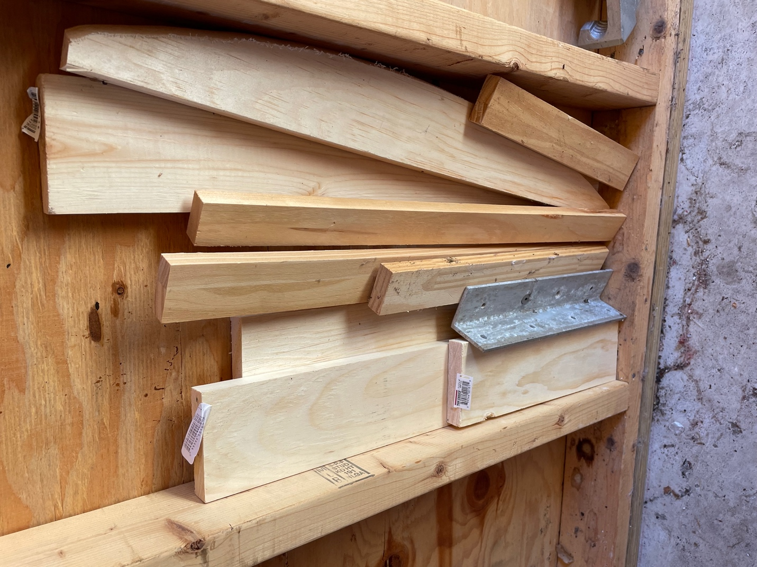

Pieces of wood various lengths and dimensions + an aluminum bracket

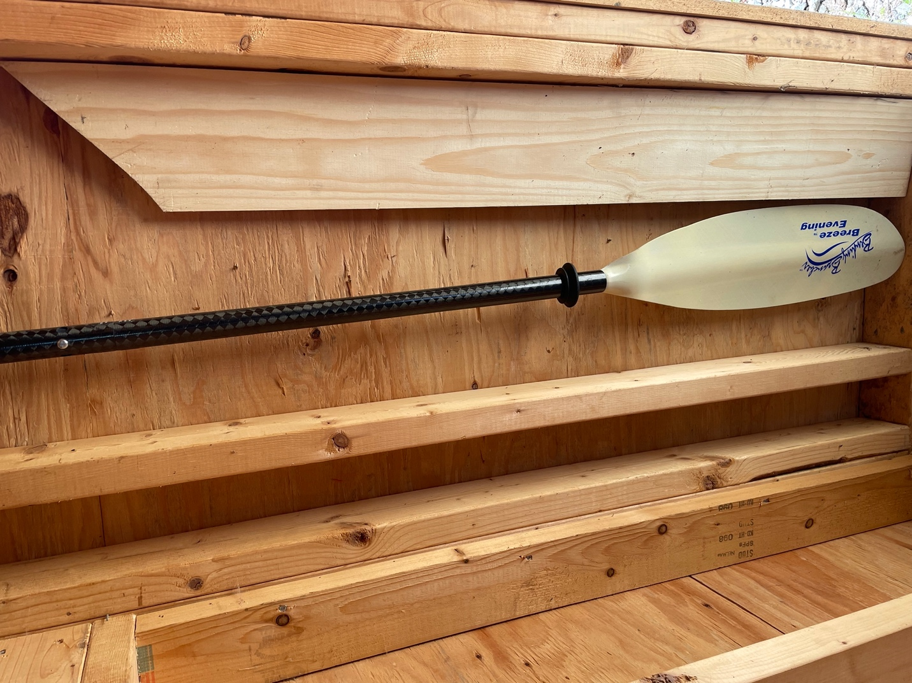

Kayak Oar and angle cut lumber

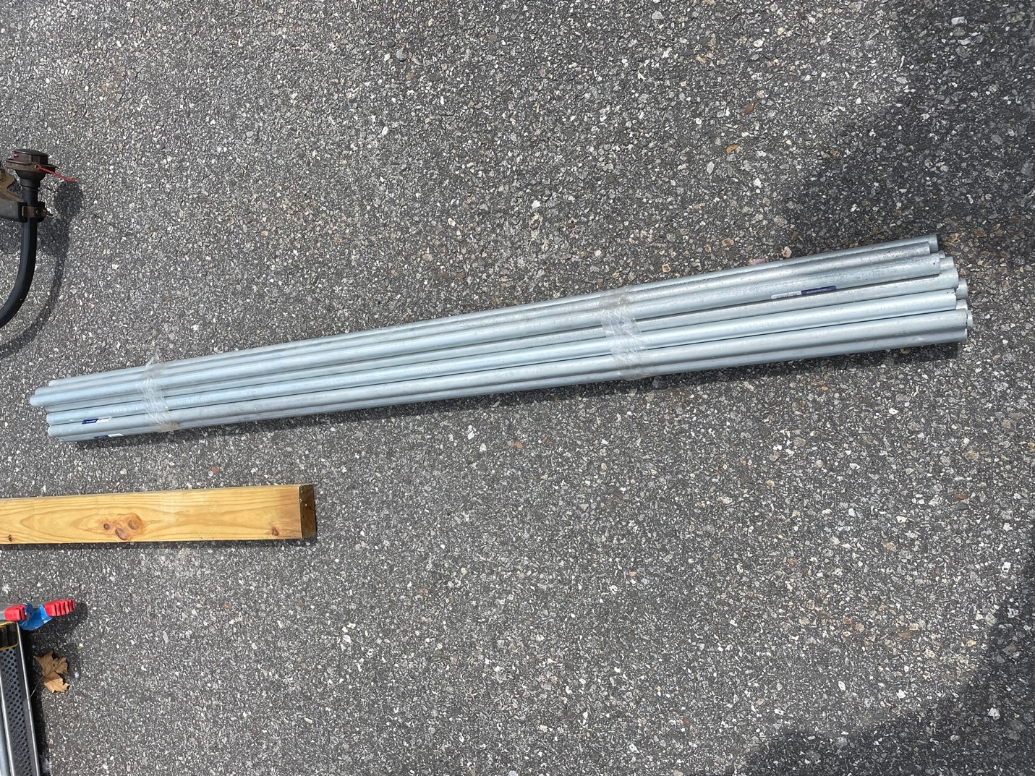

Multiple aluminum poles + 2x4

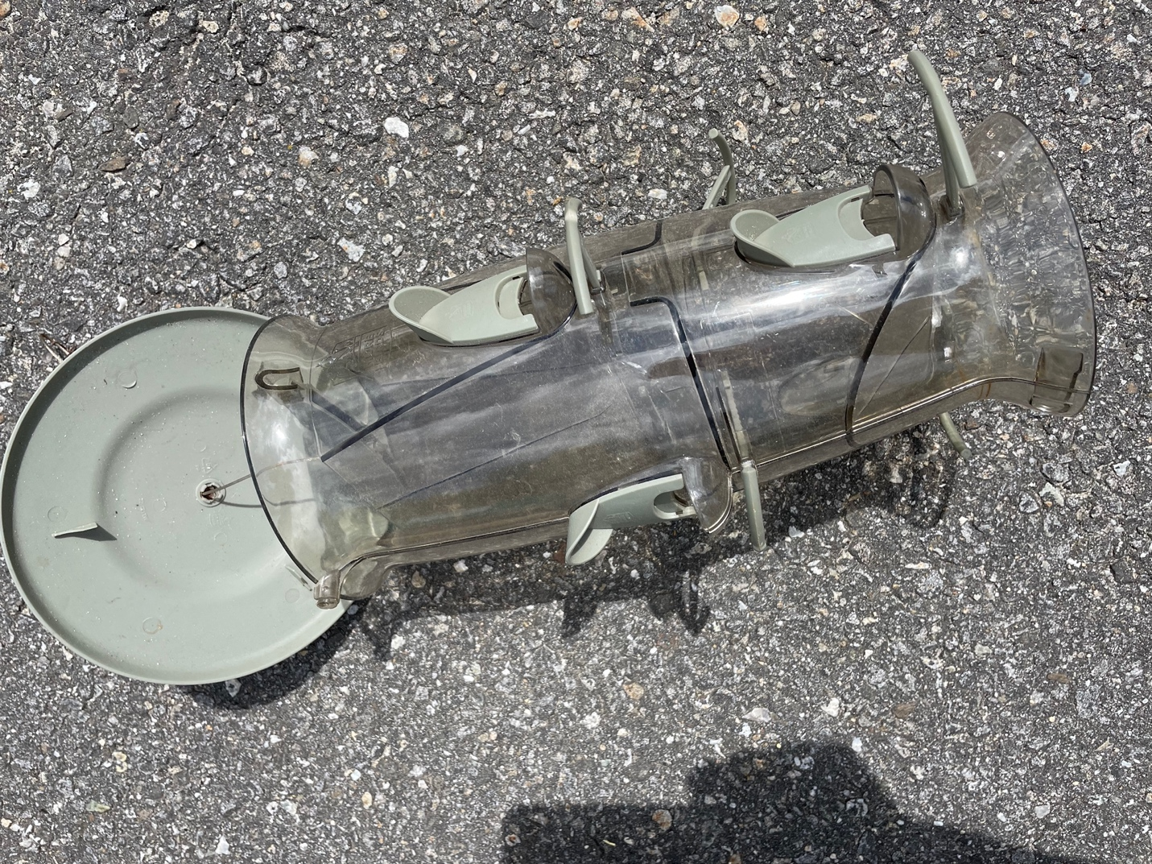

Bird Feeder

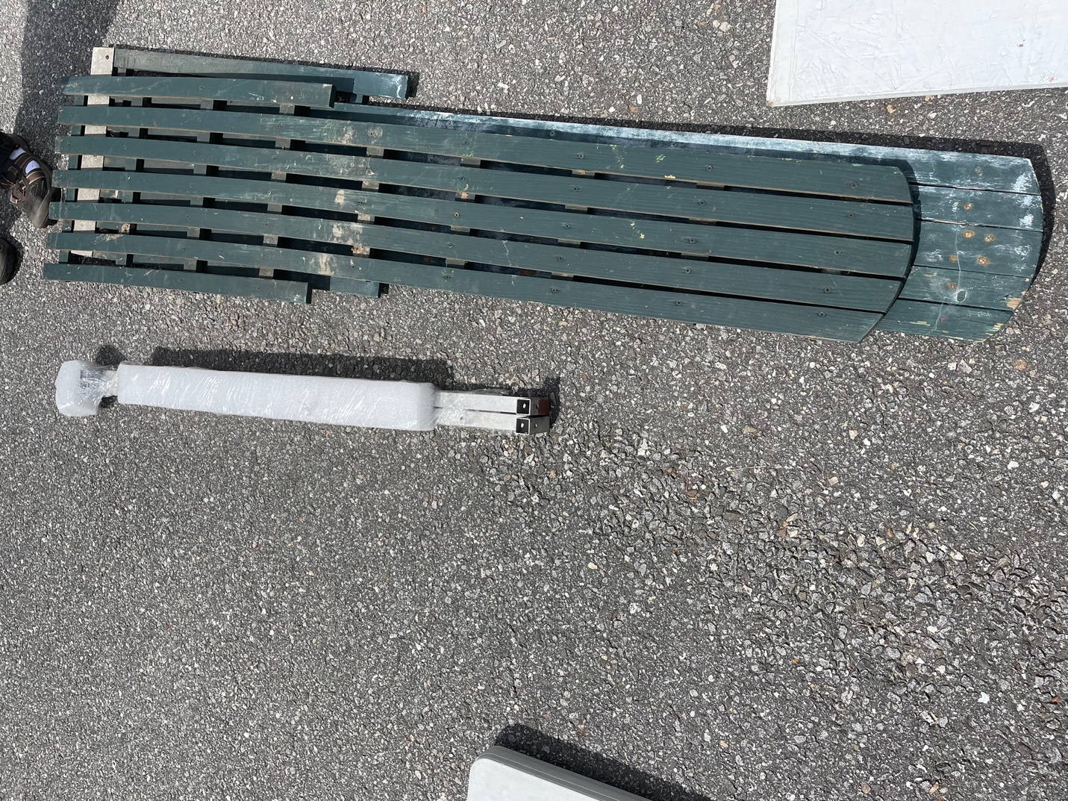

2 green garden lattices

Carefully wrapped aluminum braces

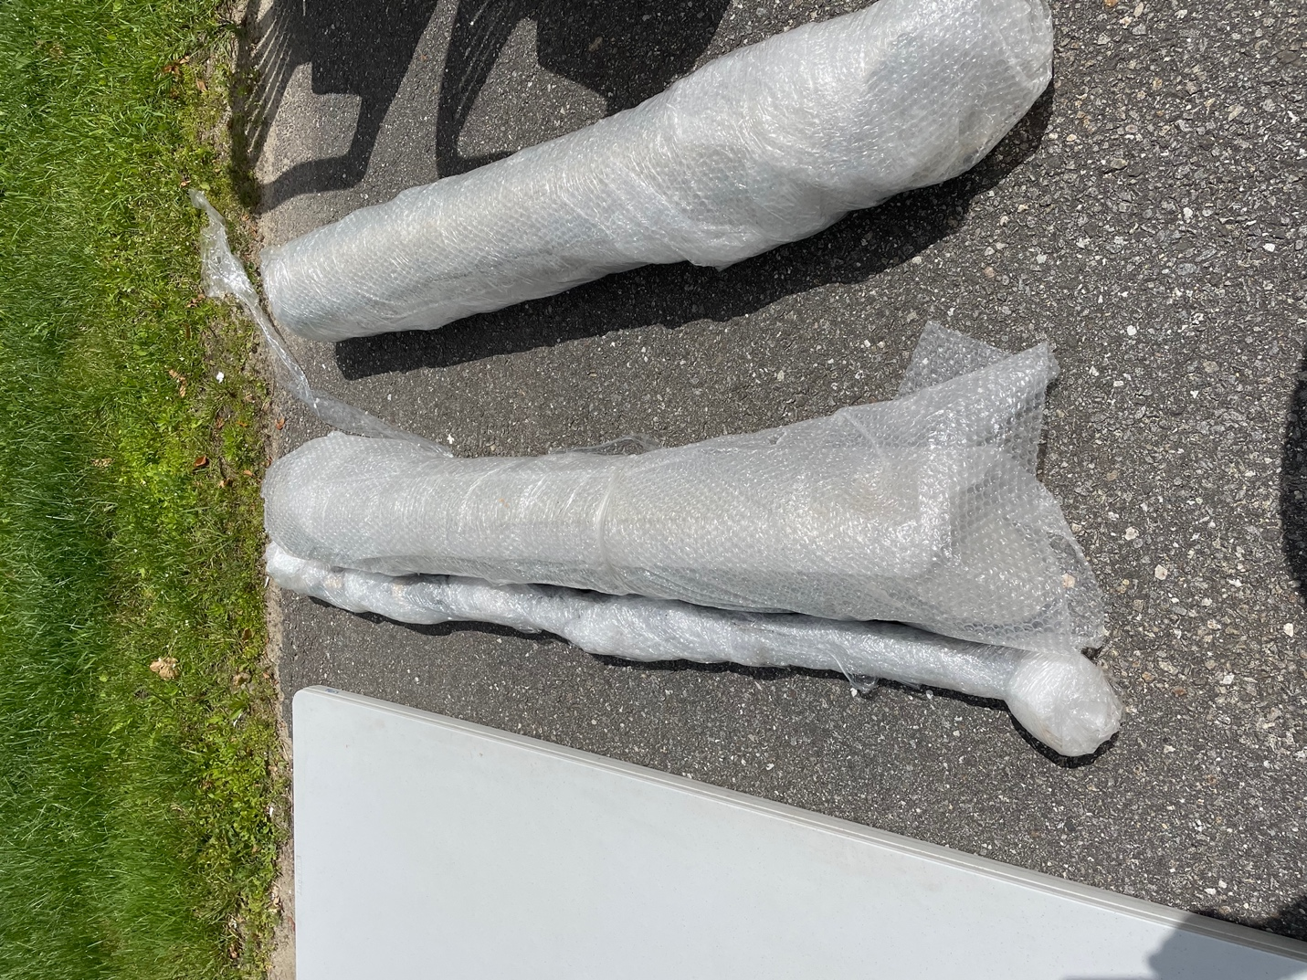

Carefully wrapped aluminum cylinders (2) and a longer aluminum pole

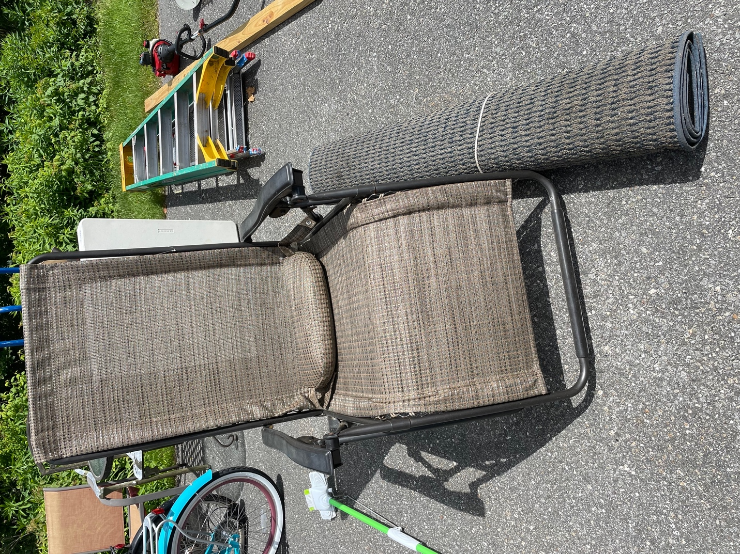

Lawn recliner and green handled mop. Rug was donated to the dump by current owner.

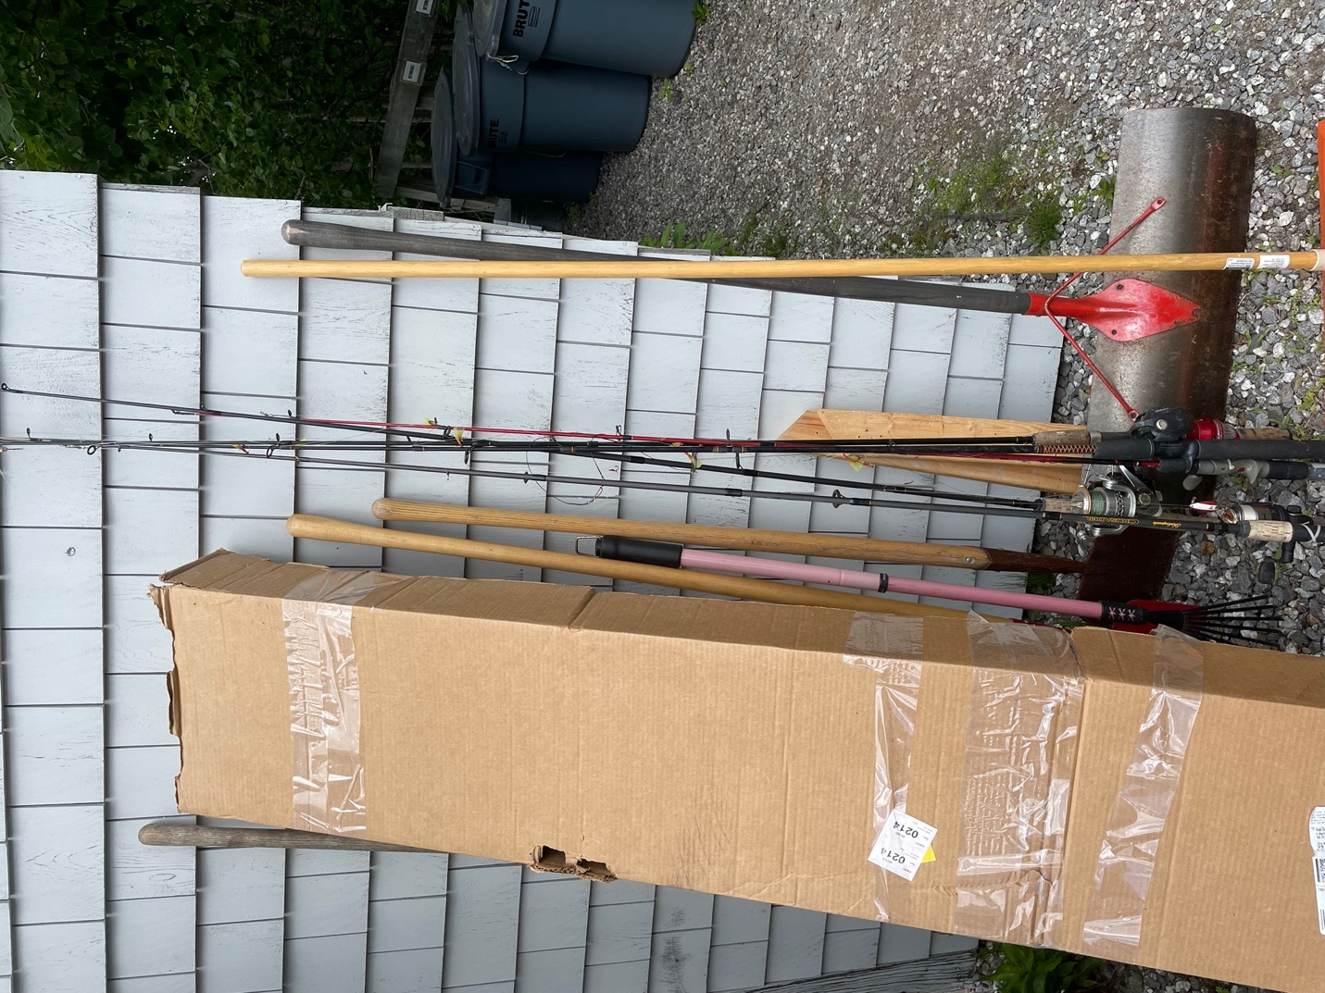

Multiple fishing rods

Multiple garden rakes, spades

Multiple snow shovels

Large box was claimed by owner

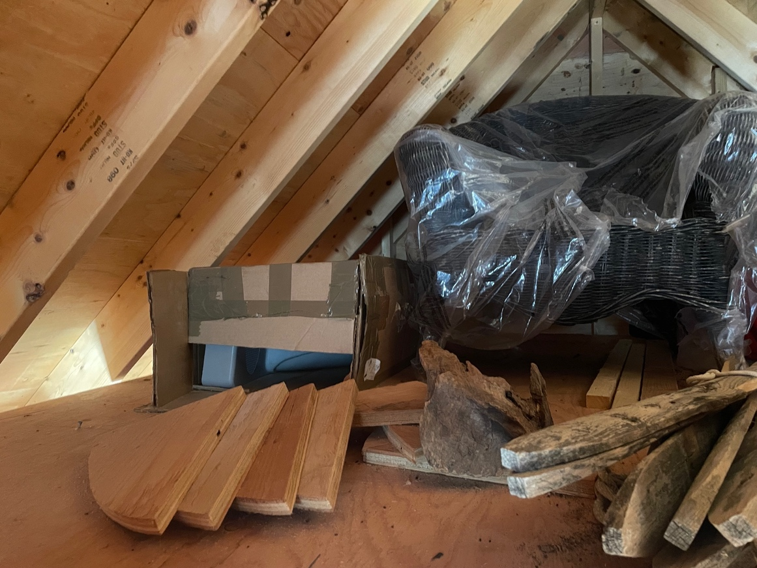

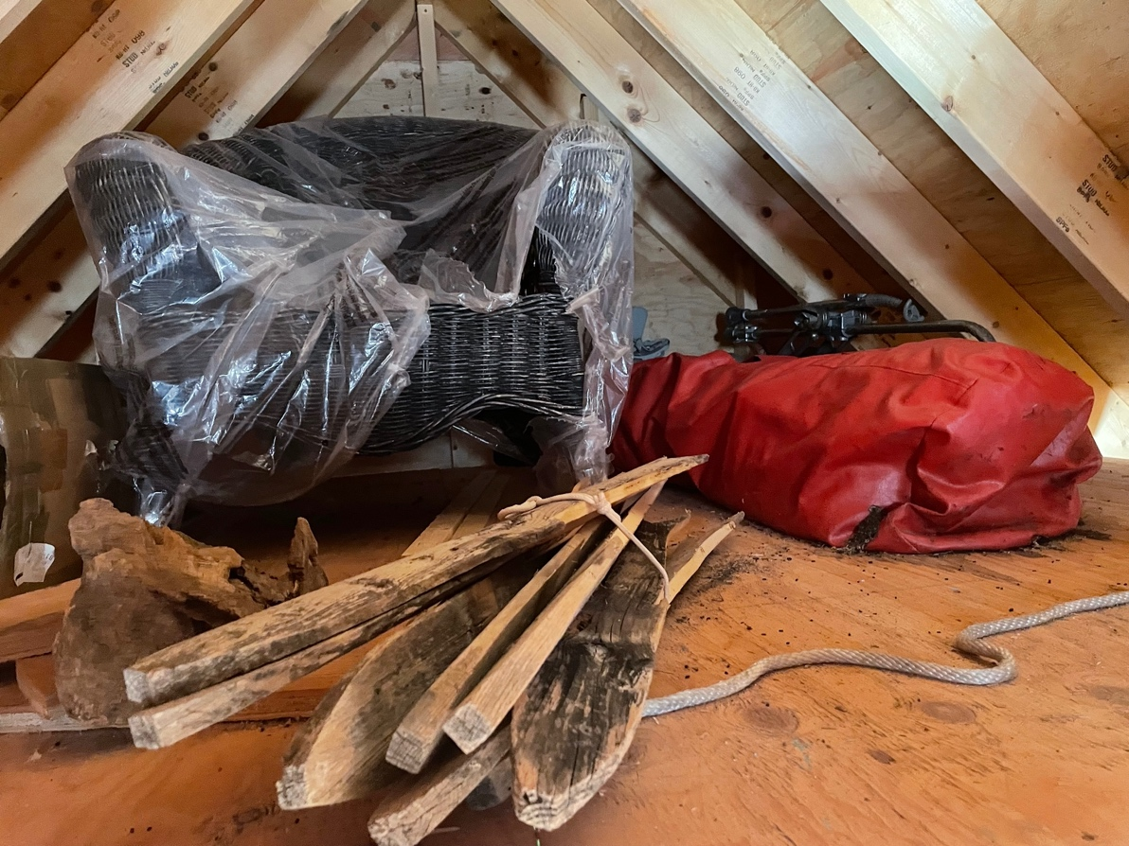

Large chair, uniquely cut lumber, odds and ends in the Attic of the shed.

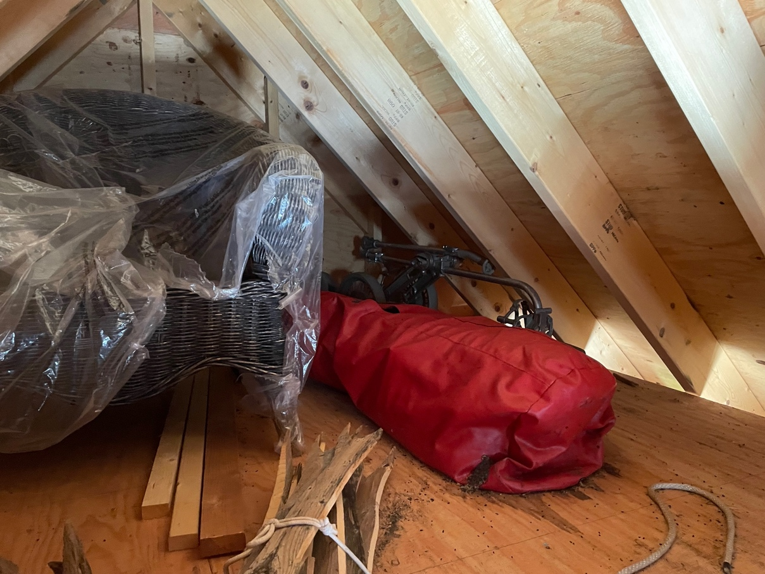

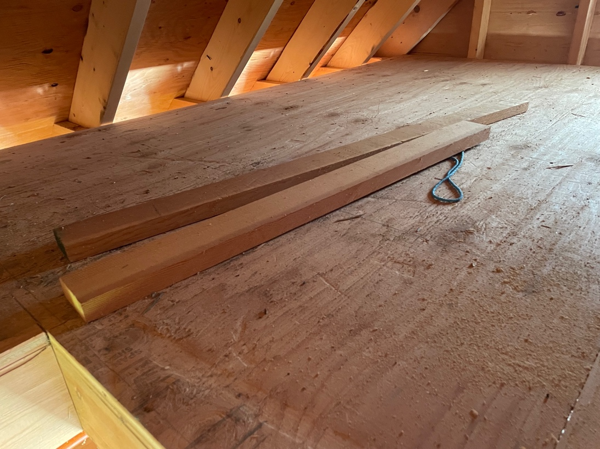

More 2x4 in the Attic of the shed

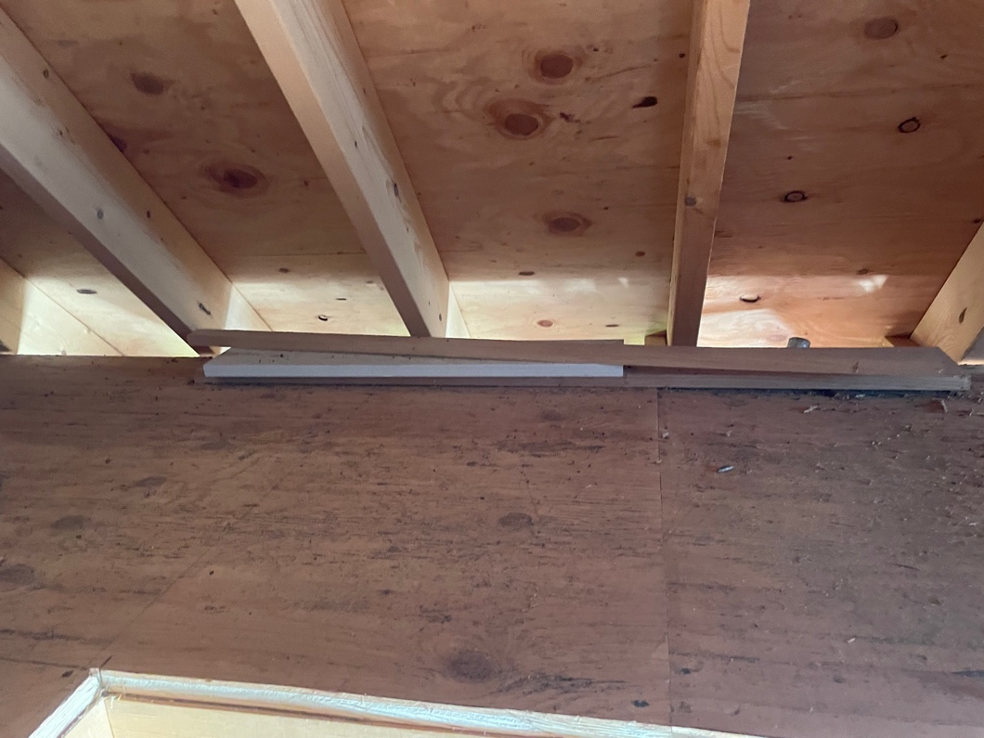

Ice cream maker and King Kooker

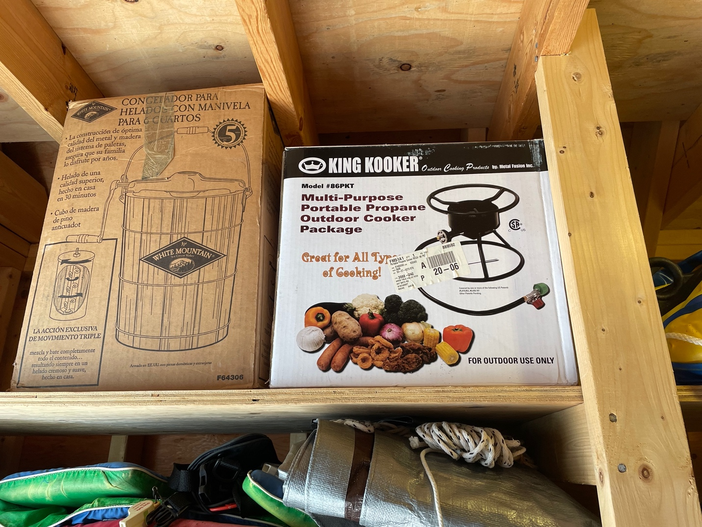

Entire shelf left of the door of odds and ends with electrical extension cords (orange + yellow). Flares expired July 1987.

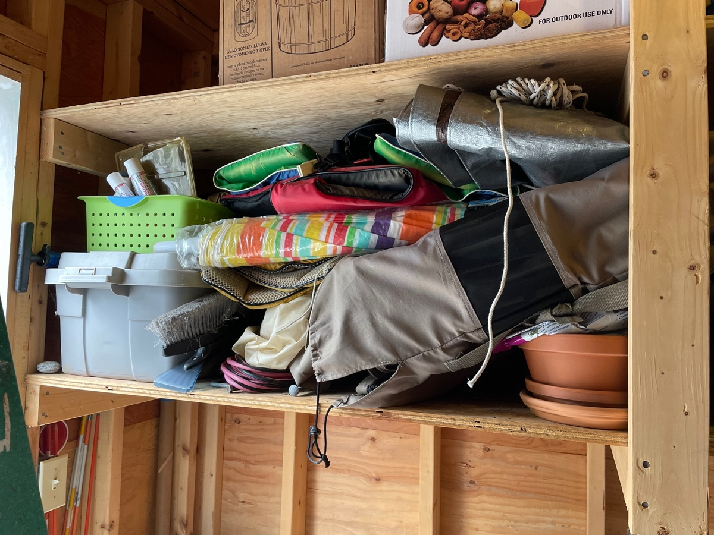

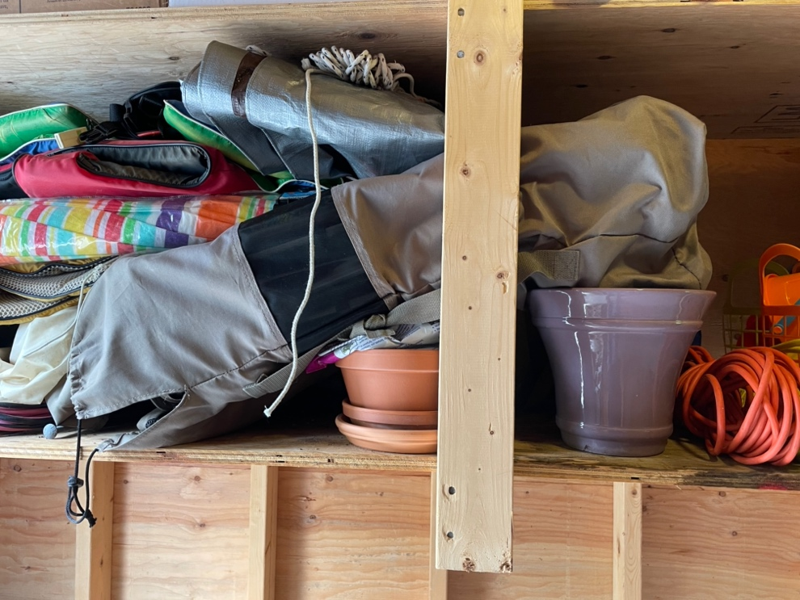

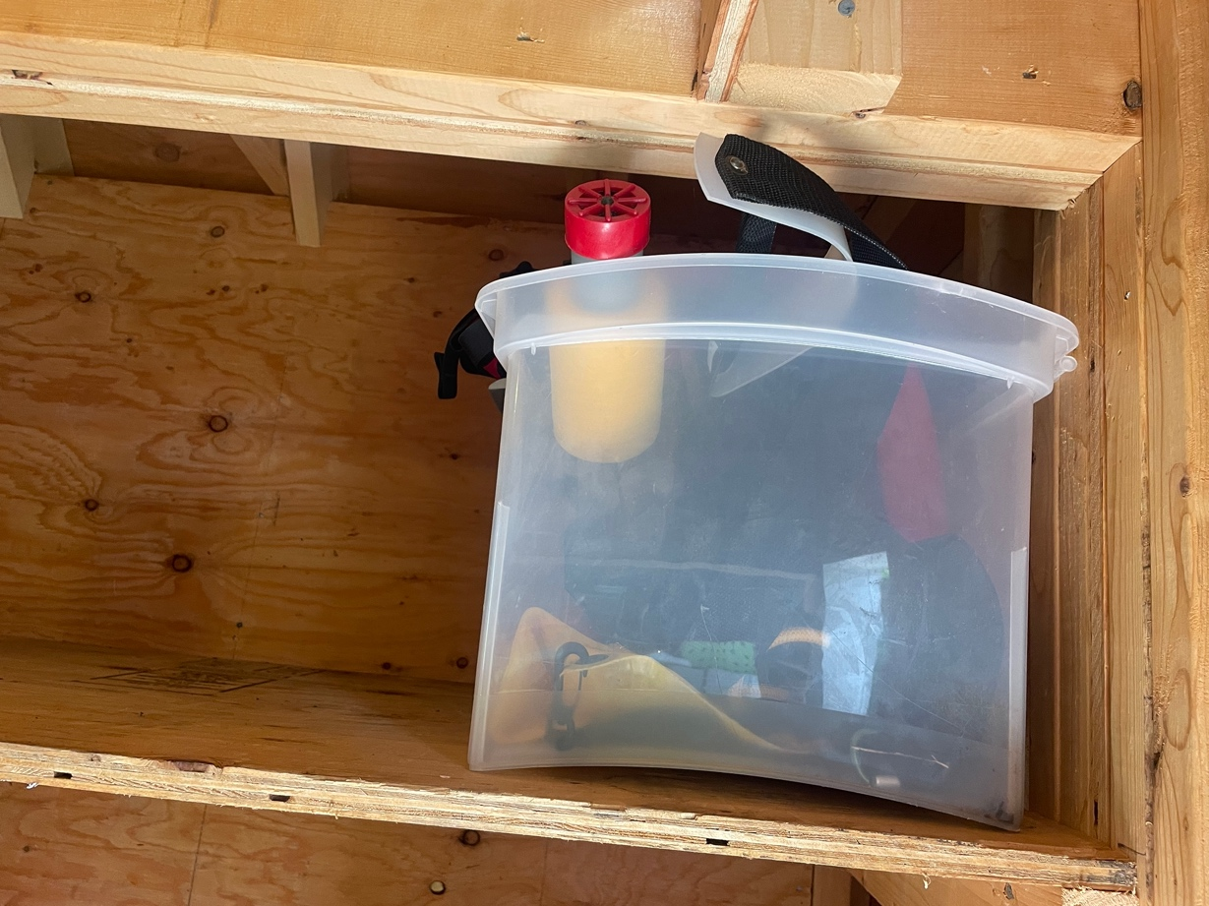

Box to right of door with odds & ends

Boogie board, black vest (kayak maybe), funnel, rope

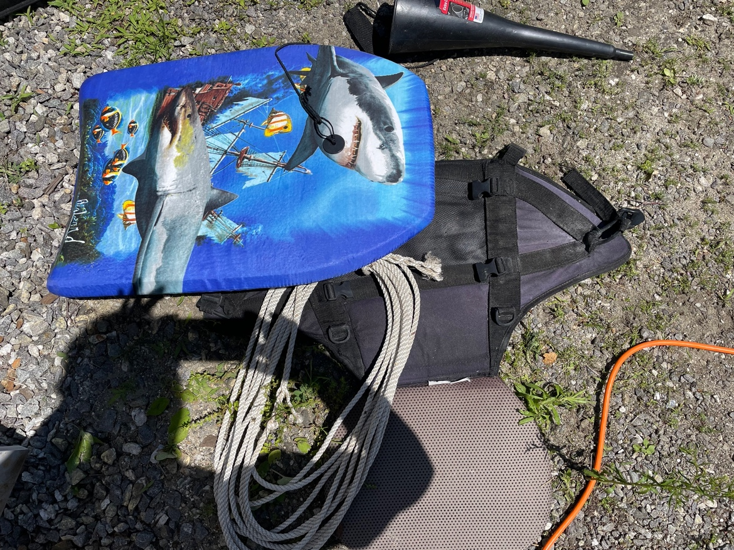

License plates last valid 2013; license plate dustpan, hand broom

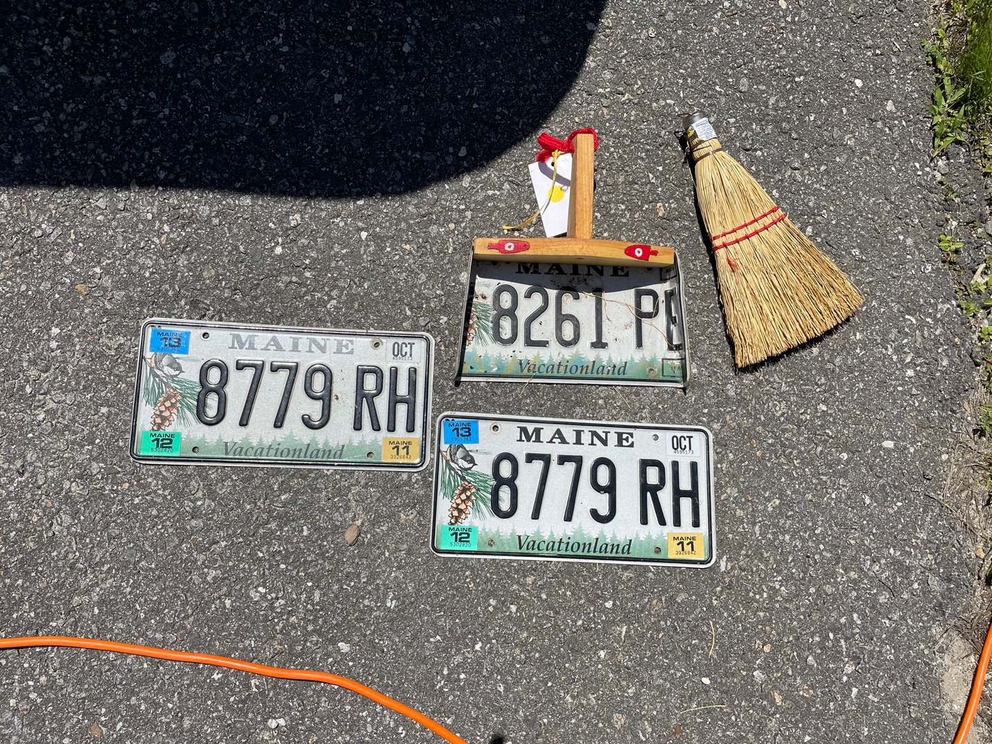

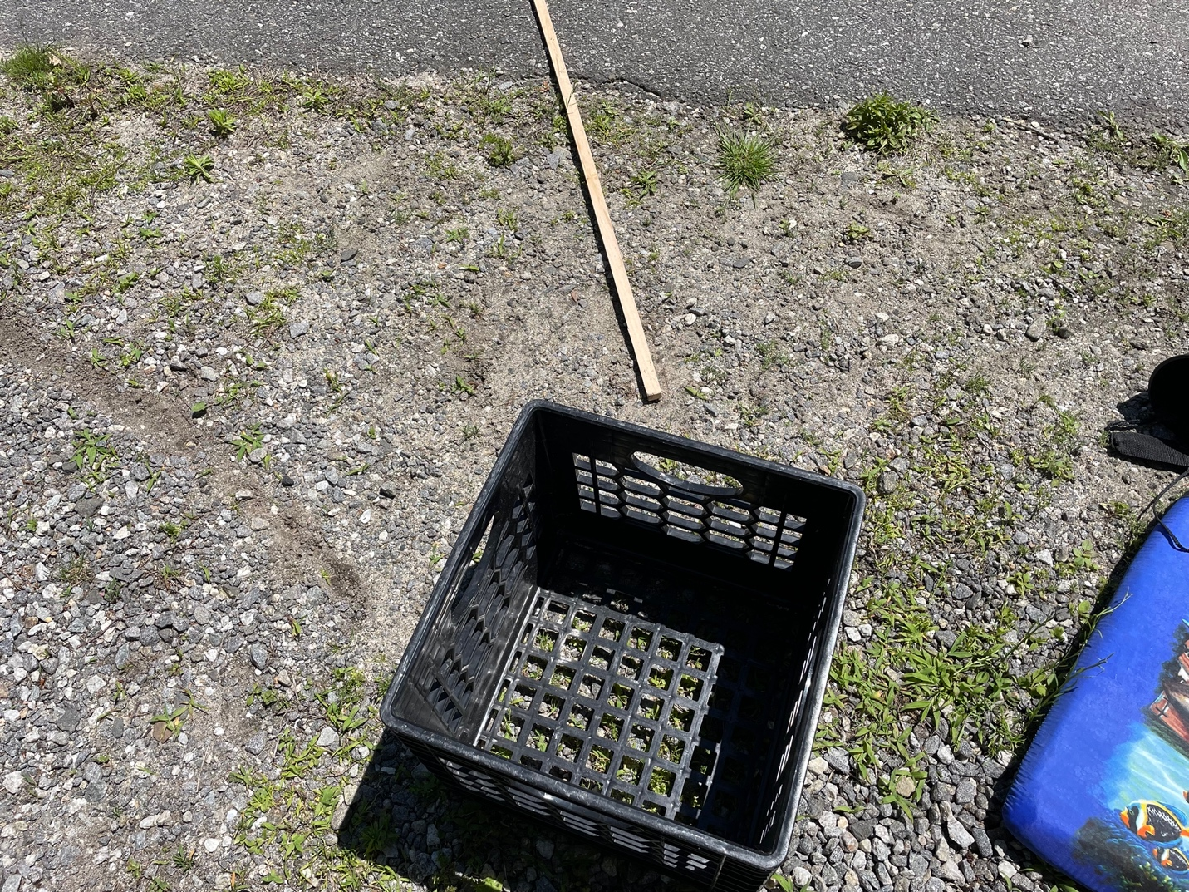

Milk crate